BURKOT, Mikhail

IFB299 – THe good BOYS it user manual

User Guide – A “How To” in Using Our Website

Contents

Greeting Home Screen 2

Bug Reports 2

Registering an Account 3

Logging In & Out 4

Modifying Account Details 5

Refer a Friend 6

Search Locations 7

Reviews 8

Suggest a Location 8

Conclusion 9

# Greeting Home Screen

Welcome to a ‘How To’ guide on using our website. This manual will undergo a series of headings to provide to you on the features that the website has to offer and how to use them. Now let’s begin with the home screen.

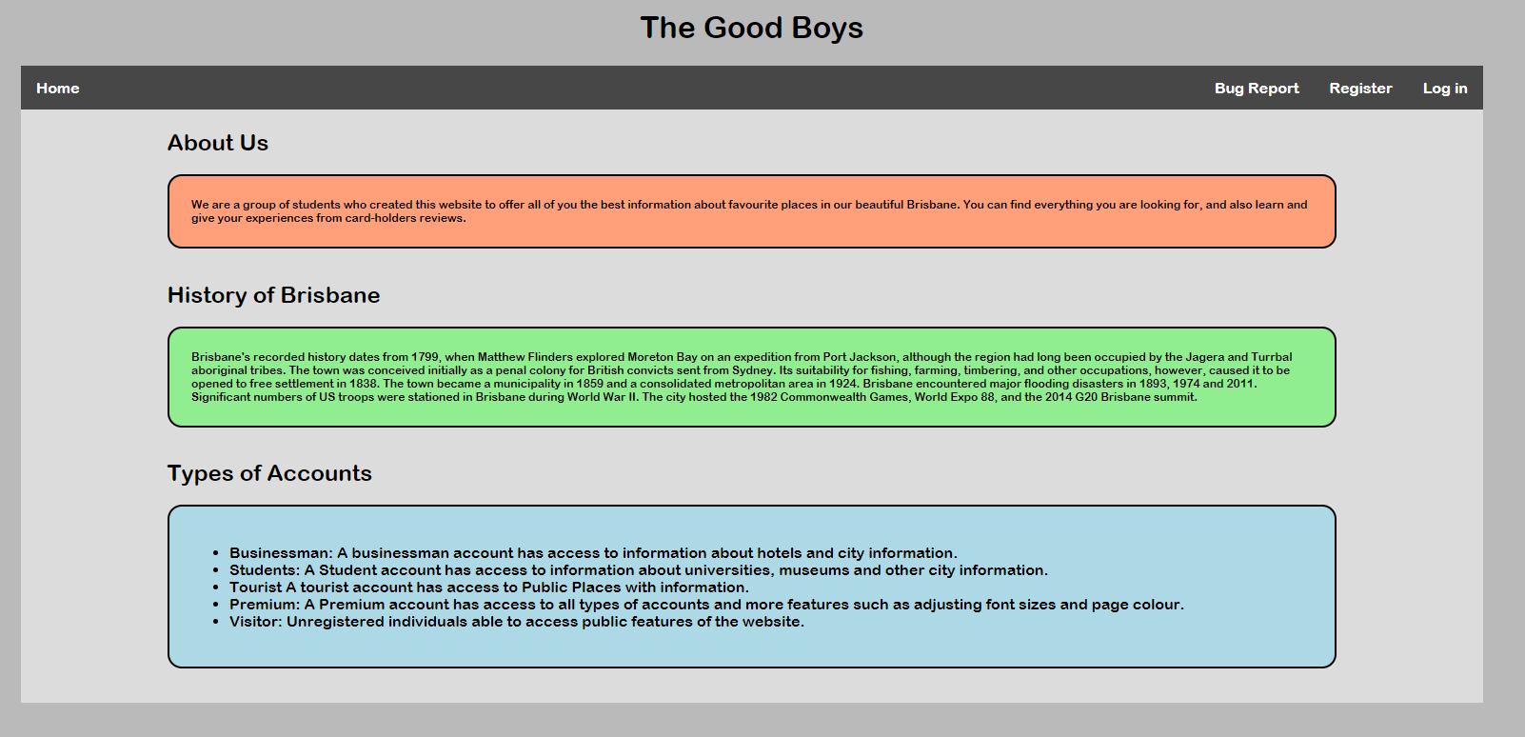

Upon arrival onto our site you are greeted with the sites home screen. On this page, you are presented with information regarding about us, history of Brisbane and the types of accounts available upon registering. Also notice that we have a global navigation bar across all our webpages to ensure that you can easily navigate on where you want to go.

# Bug Reports

One of the features that we have publicly enabled was the bug report feature. This feature can be accessed by anyone and they are able to submit any type of bugs that have occurred.

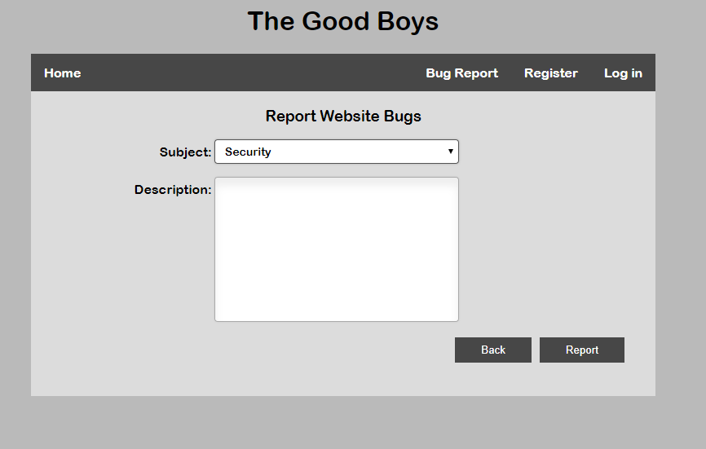

To submit a bug report, click on the bug report button in the navigation menu. Once clicked it will take you to the bug report html page. Select the category of the bug (security, visual bug, feature not working, website crashing or other), add a description and then click the report button. And you’re done!

# Registering an Account

To access the account features that the website has to offer, you must first create an account within the website. To do so, navigate to the ‘register’ link within the navigation bar and click it. Once clicked you should arrive at the registration page where you can fill out the following details:

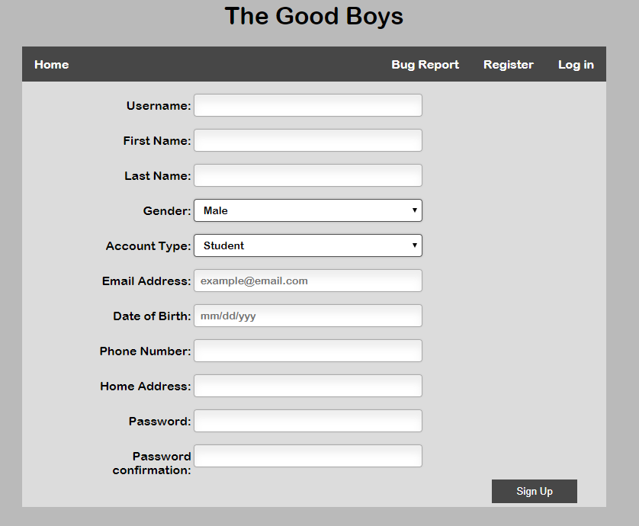

To ensure the best experience please select the account type in which you are most associated with. Once complete press the sign up button to continue on to the login stage.

# Logging In & Out

Once you have created an account you will automatically we taken to the login page for you to enter your credentials.

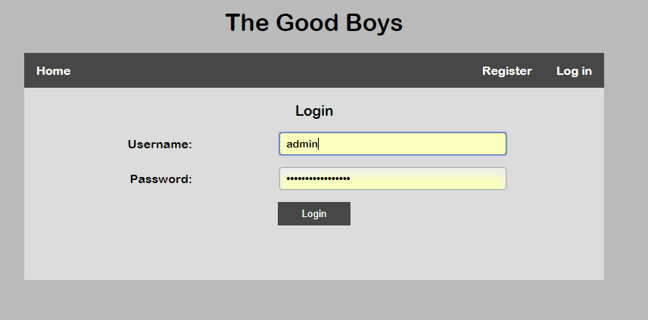

Please enter your username in the first text field that you previously created, followed by the password in the second field. Once complete press the login button. Upon a successful login, you are greeted back to the home screen with various number of new features located in the navigation bar. Before you continue to use these features, the logout button is located on the very right of the navigation bar – if you ever need to end your session.

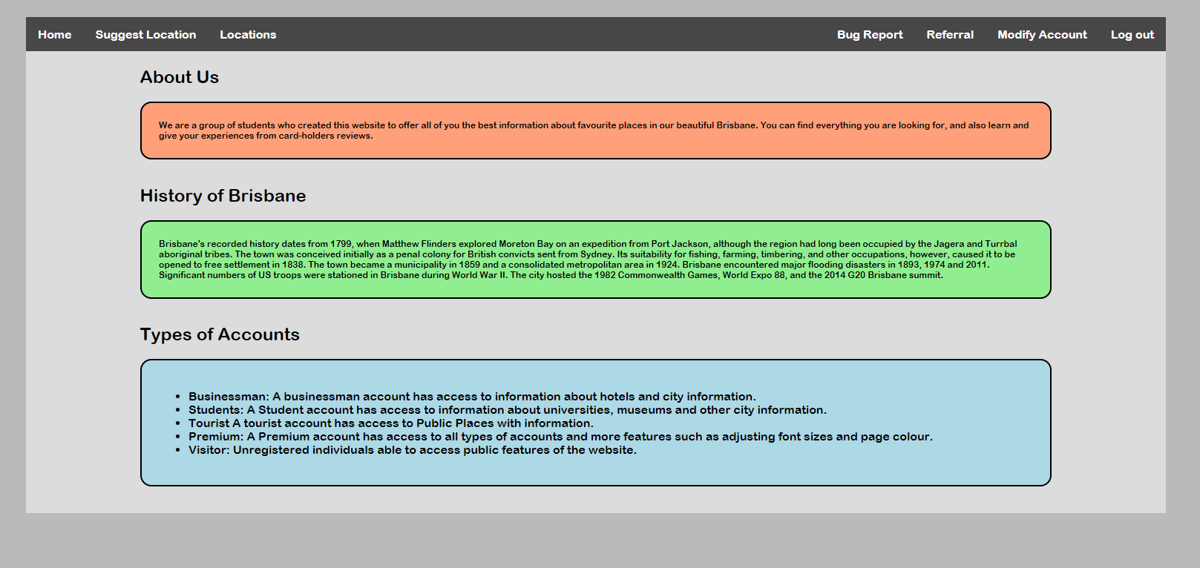

# Modifying Account Details

As mentioned there are numerous features that our website offers. Let us start with account modification. This feature is here to keep your details up to date within our system. By now you should know how to use the navigation menu. Navigate to the modify account page.

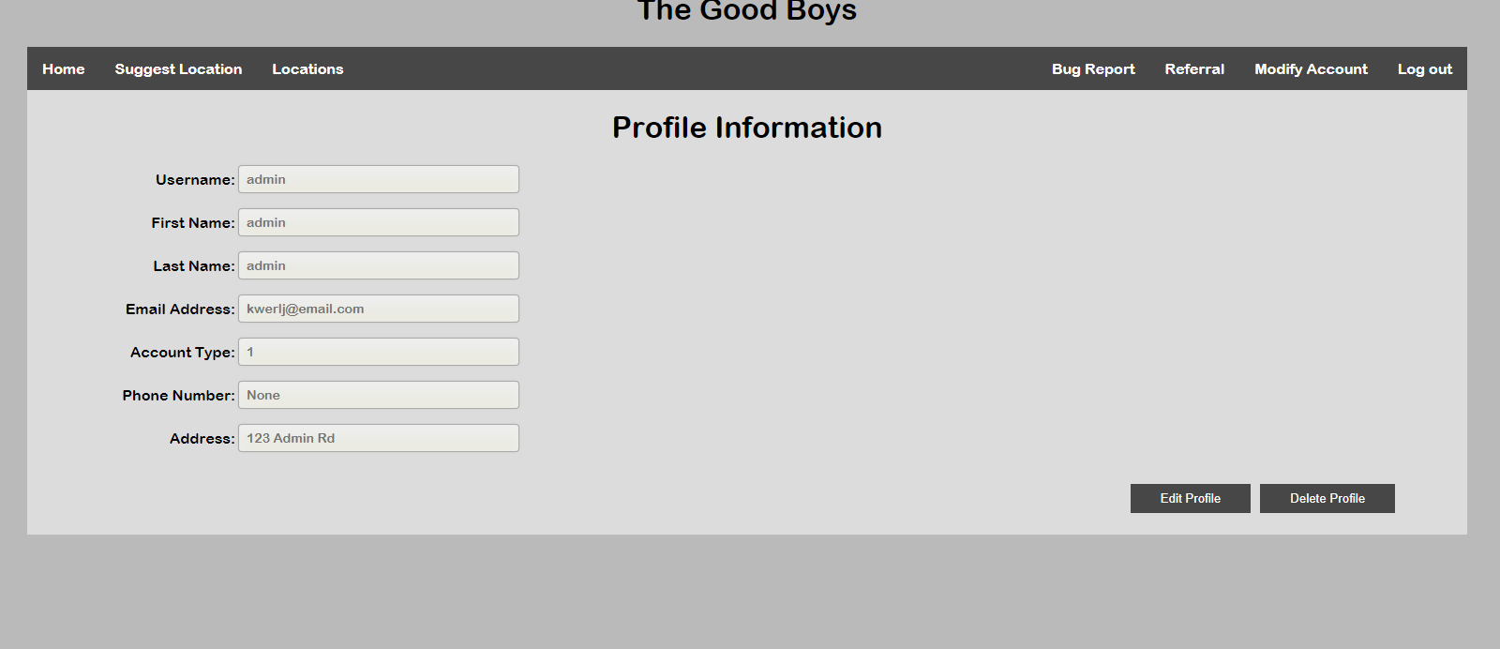

On the left-hand side of the screen you are presented with your current details that our system holds within the database. If you would like to change information regarding your profile you simply click the edit profile button on the bottom right of the screen.

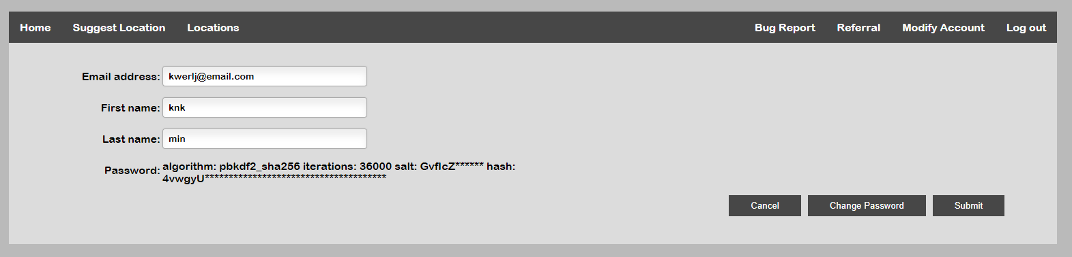

From here you can change the shown details on screen or prompt further to change your password by clicking the change password button.

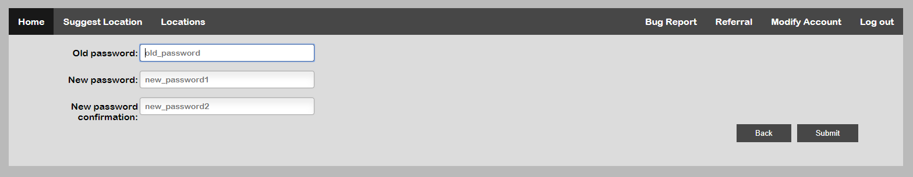

Lastly in case you want to delete your account from the website, we offer that feature. Navigate to the modify account page then delete account. As requested, type in your username to confirm deletion of our account. Once deleted it will end your session and take you back to the home page.

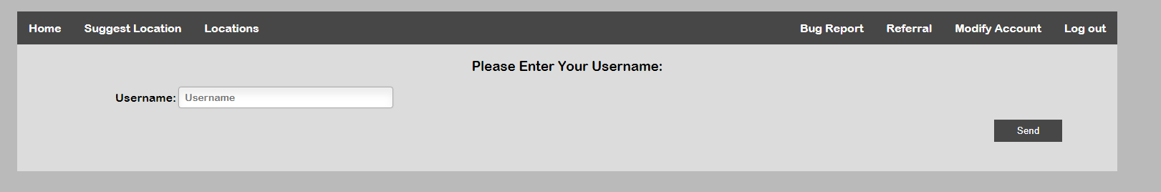

# Refer a Friend

From what you could probably already see within the navigation bar, we have a feature called referrals. Essentially this is a feature which allows you to invite a friend, colleague or anyone for that matter to sign up to the website.

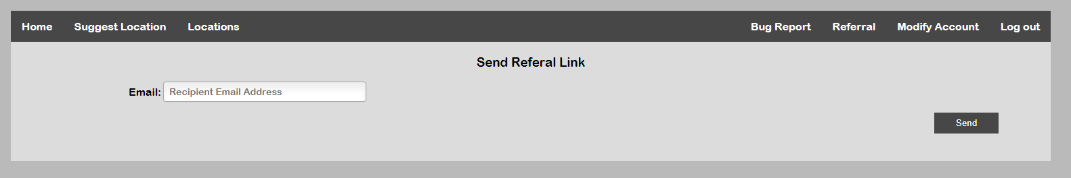

To send a referral link you must know of the recipients’ email address. Once acquired proceed to type it into the text field and click send. This process might take a couple minutes (depending on the email traffic) so please be patient. Once completed the recipient should receive the email in their inbox. On some email providers, this could be listed under ‘spam’.

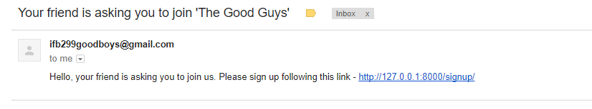

This is what the email looks like for the receiver. They presented with a message to join the website followed by a sign-up link.

# Search Locations

The main feature of this website and probably why you registered is for the location feature. To access it is the third one from the left in the navigation bar. Once clicked you are greeted with this screen:

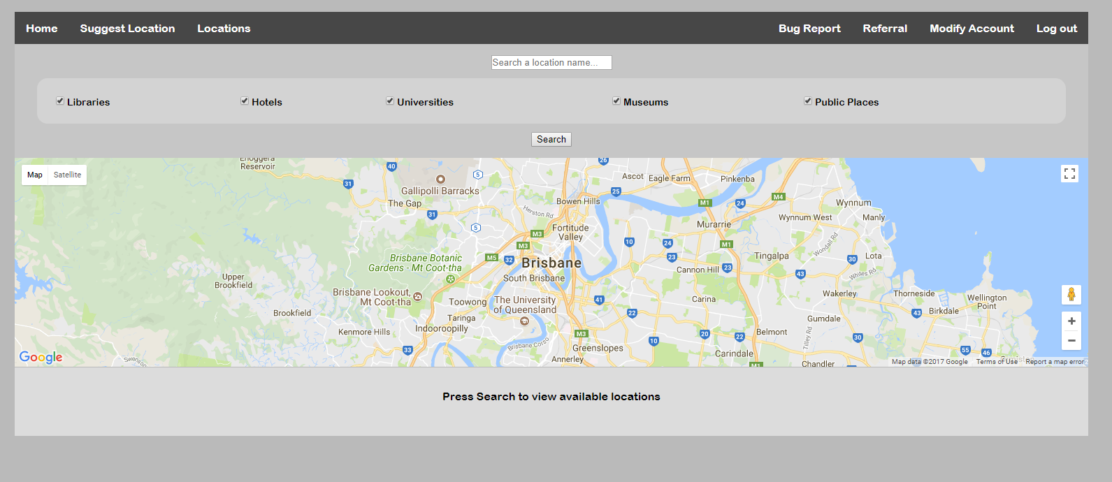

From here you can see that there is a google map (with markers), search field and radio button search fields. Here at The Good Boys we offer a range of searching solutions to make the search experience a lot smoother, easier and towards your own preference. Once you do a search you are presented with the results:

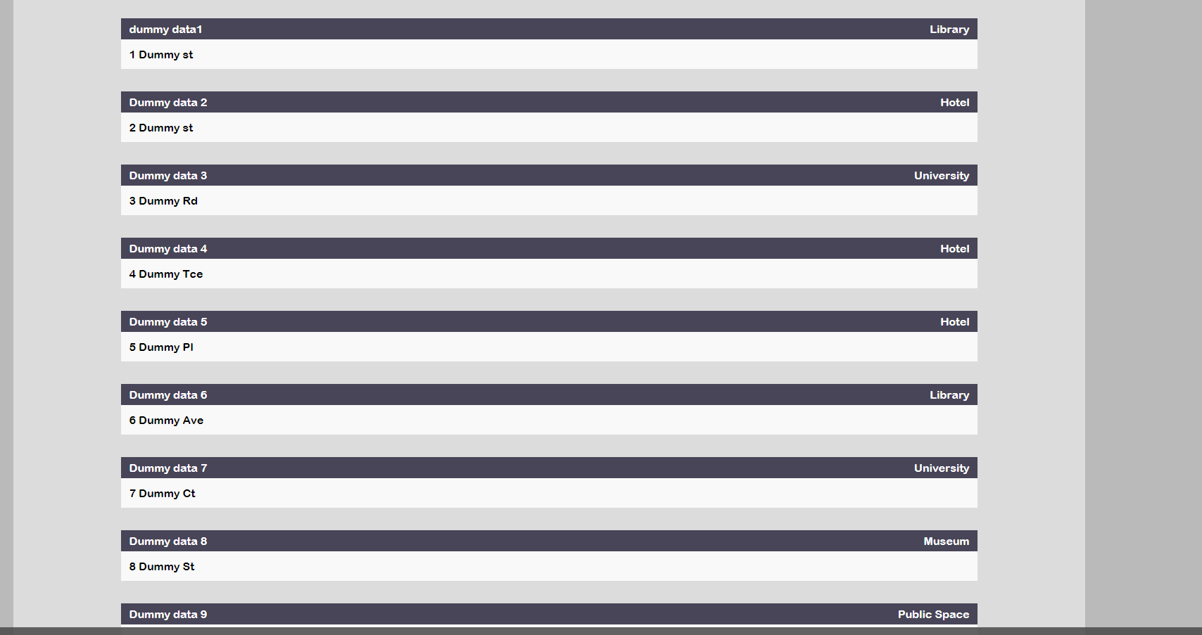

This shows what the location name is, the category it belongs to and where its located. The user may wish to click on it if they would like to see further details and add a review.

# Reviews

To proceed to the review page, click on the location result that you would like to access. Once clicked you will be presented with the reviews page which contains the location biography, details and reviews.

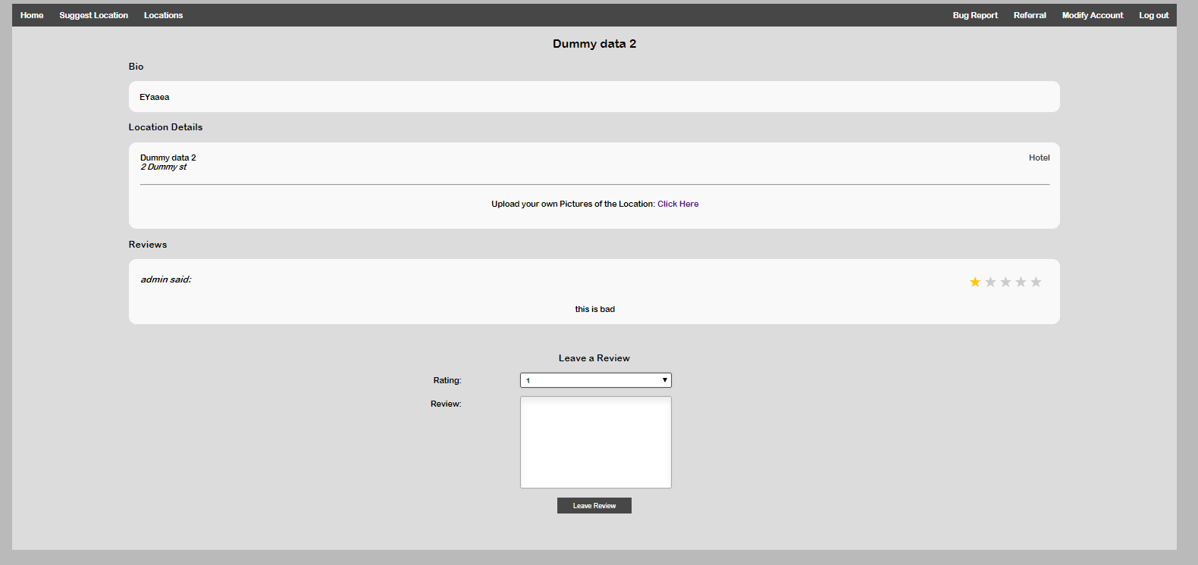

From the picture above you can see that a review has already been made from a previous user and is available to view for the public. To add a review yourself navigate to the bottom of the page where you will see an input form. Simply select a rating for that location, add a review description and click ‘leave review’.

# Suggest a Location

The last feature that is currently available to our users is the ‘suggest a location’. This allows users to recommend a location to the website that isn’t in the current database. To do so, user must navigate to the suggest location tab within the navigation bar. Once clicked they are prompted to the page which then they can will out the form and press submit. It is then processed to the admins for review.

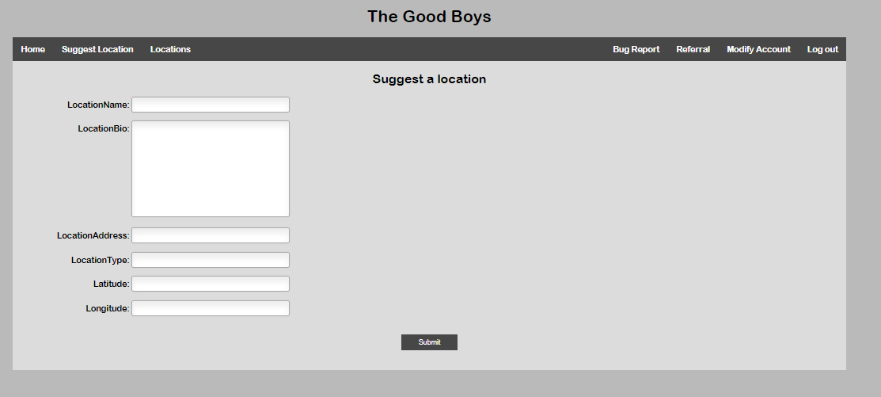

# Conclusion

I hope that this ‘How To’ guide has helped you learn and use the websites fundamentals. I would like to mention that this didn’t cover all of the features of the website. It serves its purpose for the users only. An admin base guide and its will be in another edition once the website is in full launch. Thank you for reading this guide and we hope that you enjoy our service.